Exercise 4: OpenAI API in Python
Baseline test (physics assistant)
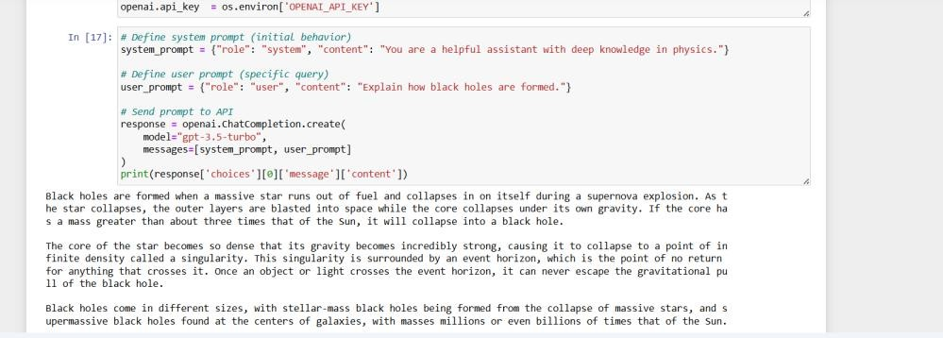

Event Planner Chatbot
System: "You are an expert event planner..."
User: "I'm planning a birthday party for my friend turning 21, 20 guests, $200 budget, at home. Give a full plan."

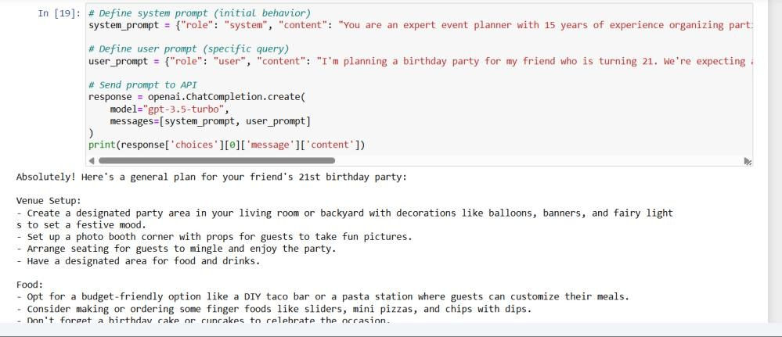
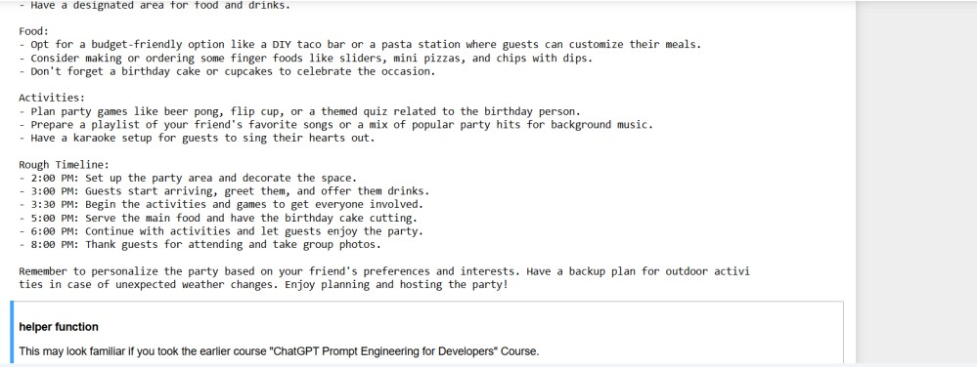

Unique Prompt: Database Systems Tutor
System: "You are a patient CS tutor specializing in database systems..."
User: "Explain what a deadlock is in database transactions, with a real-world analogy."
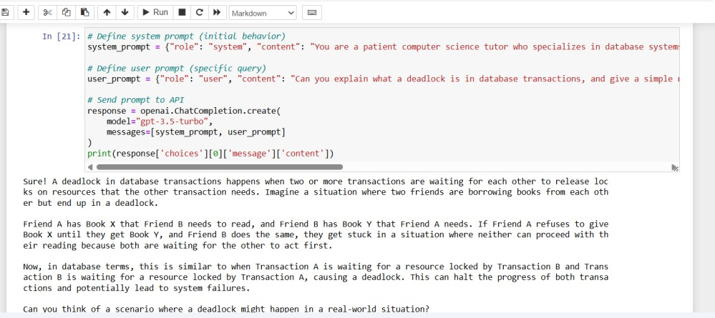

Changing the system prompt clearly changed the model's persona and output style across all three runs, while the underlying API call stayed identical.

